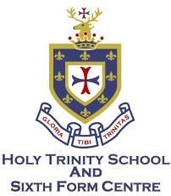
Sixth Form Application Form – Year 12 September 2023

Name *

First: Last:
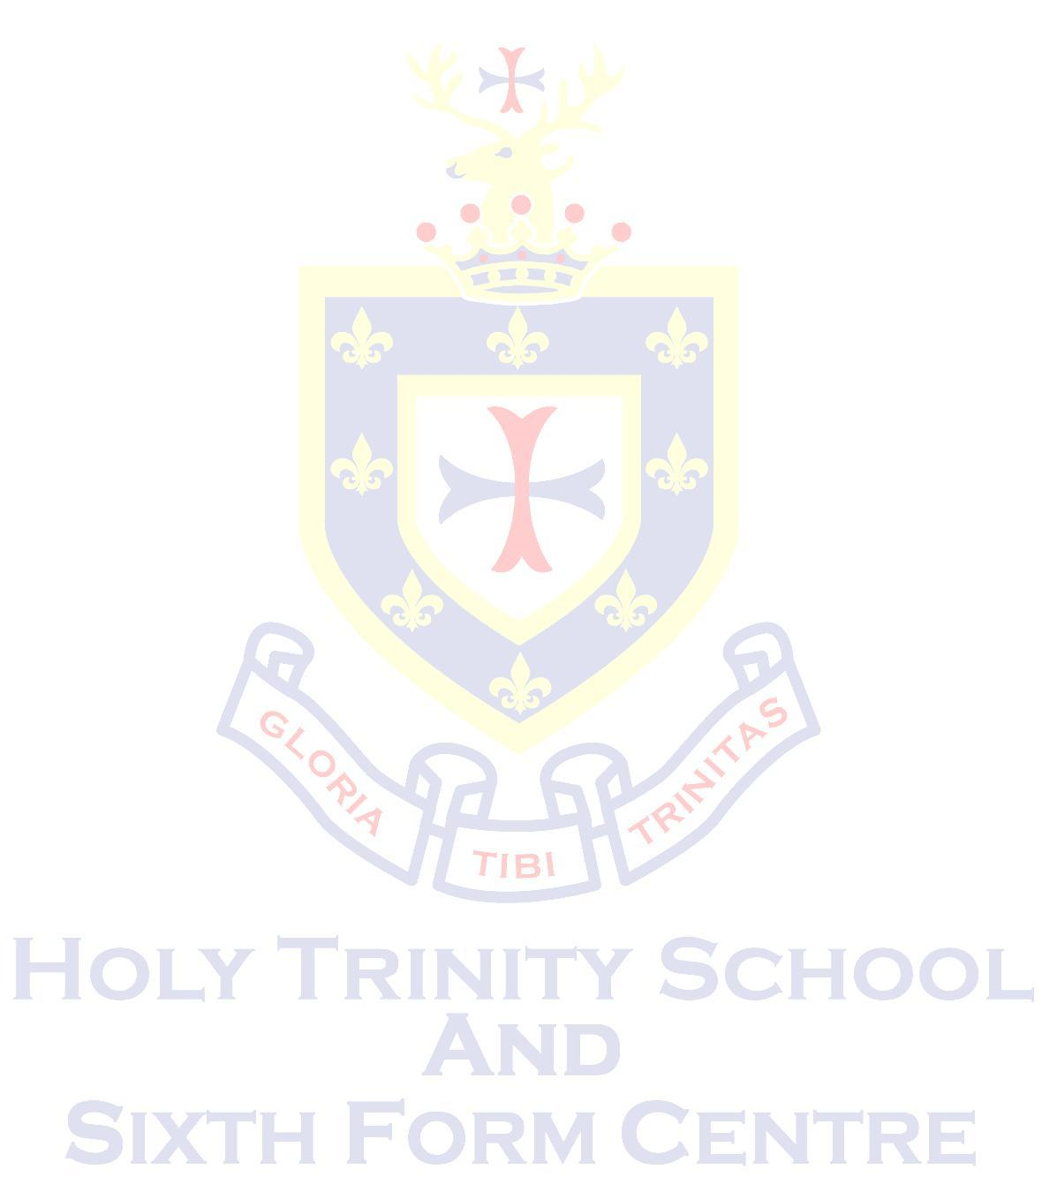
Email * Parent/Guardian Email*

Gender *

Date of Birth *

Address *

Street Address:

Town:

County:

Postcode:

Phone Number * Parent/Guardian Phone number*

Your Current School (including name and location.) *

GCSE Grades/Predicted Grades *

Subject | Grade (if applicable) | Predicted Grade
Subject | Grade (if applicable) | Predicted Grade
Subject | Grade (if applicable) | Predicted Grade
Subject | Grade (if applicable) | Predicted Grade
Subject | Grade (if applicable) | Predicted Grade
Subject | Grade (if applicable) | Predicted Grade
Subject | Grade (if applicable) | Predicted Grade
Subject | Grade (if applicable) | Predicted Grade
Subject | Grade (if applicable) | Predicted Grade

Subject: Below is a list of A Level subjects that Holy Trinity School Sixth Form is offering to students in Year 12. Please circle 3 or 4 subjects:

Art & Design/Textiles | Spanish  French | Maths
Biology | Geography | Music
Business | Graphics | PE
Chemistry | History | Physics
English Literature | Law | Psychology  Information Technology

An asterisk * indicates that a section must be completed in full
Are there any subjects not listed that you would be interested in studying?

If so please tell us:

About You:

Please give further information about yourself, including your extra-curricular activities, the contribution you will be able to make to sixth form life and what plans you have for your post-18 career.

Educational Support Needs:

Please tell us if you have any education support needs (e.g. dyslexia)

Health Support Needs:

Please tell us if you have any health support needs (e.g. a medical condition that we should be aware of.)

An asterisk * indicates that a section must be completed in full

